**OverTheWire Bandit - Level 0 Writeup**

**Introduction**: This writeup documents my experience solving Level 0 of the OverTheWire Bandit challenge, a CTF-style game focused on learning about security concepts.

**Author**: Misha Jain

**Date**: October 19, 2023

**Tools Used:**

Terminal (SSH client)

**Challenge Description:**

Level 0 of Bandit is an introductory challenge that involves connecting to a remote server via SSH. The objective is to log in to the game using SSH.

**Enumeration:**

The challenge provides the following information:

Host: bandit.labs.overthewire.org

Port: 2220

Username: bandit0

Password: bandit0

**Exploitation:**

To connect to the server using SSH, we can use the provided credentials:

ssh bandit0@bandit.labs.overthewire.org -p 2220

After entering the password (which is also "bandit0"), we are granted access to the server.

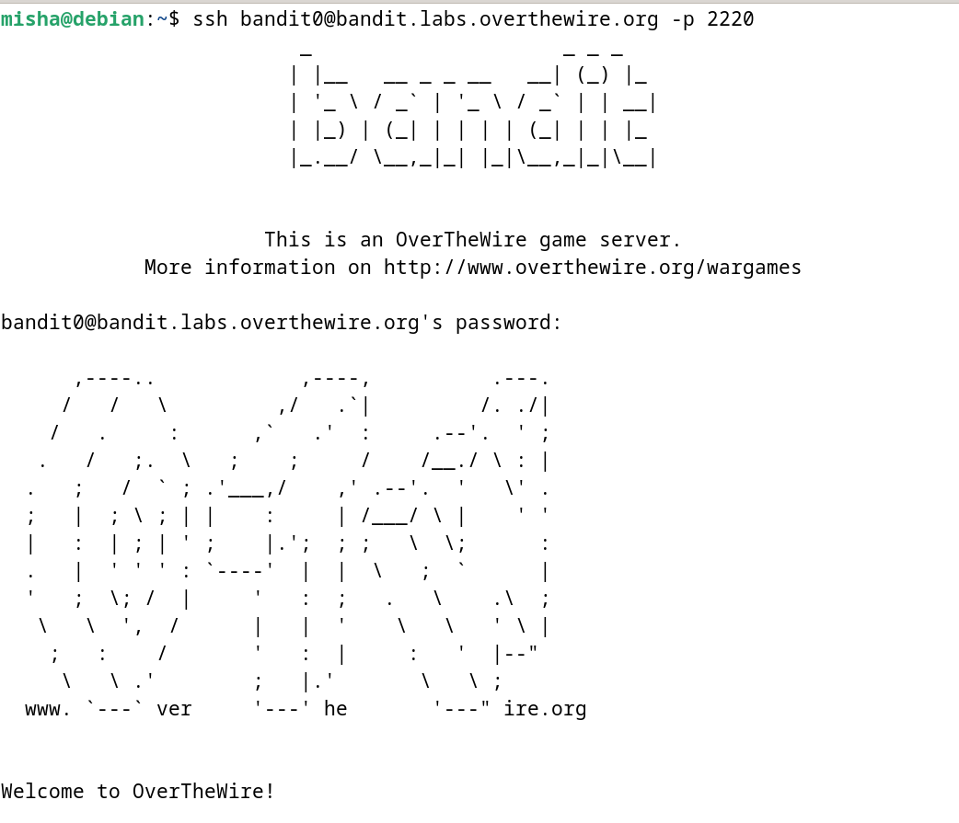

**Lessons Learned:** This level introduced us to the basic usage of SSH to connect to a remote server.

**Conclusion:**

Level 0 of the OverTheWire Bandit challenge is a straightforward introduction to SSH and basic Linux command usage. It is a great starting point for beginners looking to learn more about security and CTF challenges.